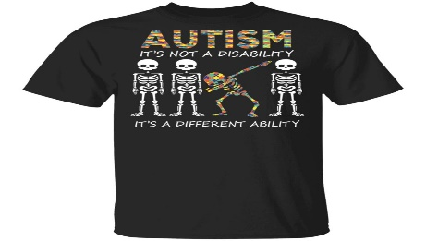
The UAW Local 685 Recreation Committee is raising awareness for Autism Awareness. In addition to the annual charity softball tournament we are selling T-shirt for $25.00 (additional cost for sizes 2XL, 3XL, 4XL, etc.) If you would like one, please get your pre-order in by August 28th. You can drop orders off at the hall (Attention: Anna Cook) or get with any of the Recreation Committee Member.
Name phone # Plant Size

