UAW Local 685 Recreation Committee is raising money for Autism Awareness through a charity softball tournament. Teams will be made up of UAW Local 685 members in good standing (at least 3 women on the field). Teams can have a maximum of 15 players. There is a $400.00 signup fee to pay for team jerseys and umpires. Teams are encouraged to obtain sponsors. All fees, rosters, shirt sizes, and team names must be turned into the Recreation Committee no later than September 11th at 4pm. All teams must send one representative to the information meeting (date and time TBA closer to tournament day). The meeting will consist of picking up team jerseys, rules, and asking questions. Players must play on teams from their home plants. That way the trophy can reside at the winning team’s plant until the following year when the new champions claim it. It is also the chance for healthy competition and bragging rights between the plants. There will be a homerun derby on the teams down times and between games for a chance to win 1st, 2nd, and 3rd place prizes and to be named “King” or “Queen” of the diamond. For questions: nobodydoesitlikeyou@hotmail.com or leave a message at UAW Local 685 (765)459-3133
When: October 10th and 11th
Where: 175 N county Rd. 100 W.
Northwest Park Kokomo In.
The UAW Local 685 Recreation Committee looks forward to another great tournament and let’s Play Ball!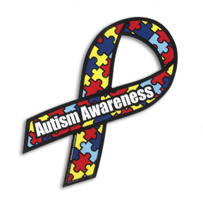 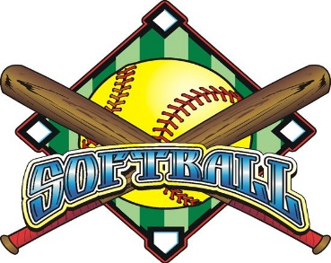

/kjp-opeiu#1-afl-cio

